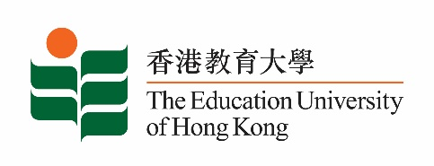

**致：**  **传媒机构采访主任**  27 January 2025

**To : News Editors**

**香港教育大学2025年 1月27 日至2月9日可供采访之活动一览**

**The Education University of Hong Kong (EdUHK) Events Calendar for 27 Jan – 9 Feb 2025**

本校诚邀　贵机构派员采访下列活动。传媒查询，请联络教大传讯处（电话：2948 6050）。  
You are cordially invited to cover the events below. For media enquiries, please contact the Communications Office at 2948 6050.

以下活动或有人数限制，传媒请预先向主办部门登记。

There may be restrictions on the number of participants for the following event(s). Please contact the respective organiser(s) / department(s) for prior registration.

* **教大大埔校园** （新界大埔露屏路十号） / **EdUHK Tai Po Campus** (10 Lo Ping Road, Tai Po, New Territories)

|  |  |  |  |  |  |
| --- | --- | --- | --- | --- | --- |
| **日期**  **Date** | **时间**  **Time** | **活动**  **Event** | **地点**  **Venue** | **主办部门及公众查询**  **Organiser &**  **Public Enquiry** | **备注**  **Remarks** |
| 2025-02-05 | 11:00 am-12:00 noon | Melodic Flow  Guest: Ms Chan Sin,  Mr Tan Cong, Mr Zheng Yang | 教大大埔校园图书馆创艺教室 C 座1楼1F室C-1/F-01F, Creative Arts Room, The Library, EdUHK Tai Po Campus | 主办部门 / Organiser:  教大大埔校园  文化与创意艺术学系 Department of Cultural and Creative Arts,EdUHK Tai Po Campus  查询 / Enquiries:  吴小姐Miss Ng  Tel /电话: 2948 7945 | 免费入场，  欢迎各界人士参加。  Free admission.  All are welcome. |